**Probability and Statistics - IT2120**

**IT24103090**

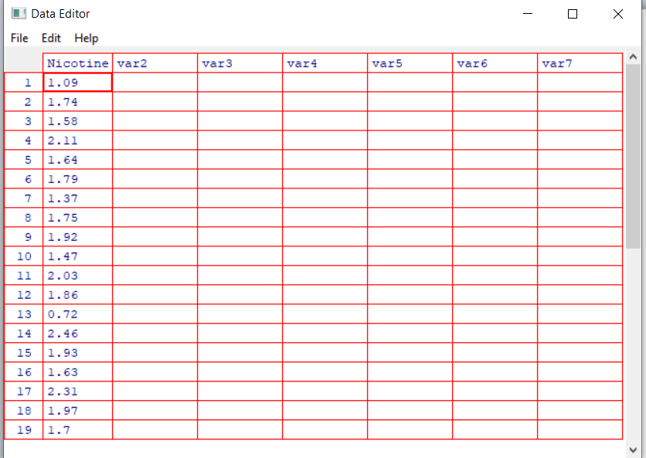



**Q1**

**Q2**

**Q3**

